 

Edge Fall Detection

Functional Specification

IoT Cart

Contents

Change Log 2

Purpose 3

Azure Services 3

Services Used 3

Architectrue 3

Required Hardware 3

Hardware 4

Schematic 4

Sample Code 4

Appendix 5

# Change Log

|  |  |  |
| --- | --- | --- |
| **Date** | **Author** | **Update** |
| 4/3/2020 | Mike Roshak | Created template |
|  |  |  |

# Purpose

This document show how to how to set up an IoT Edge device to run machine learning models on the edge device that monitor worker saftey. Some of the things monitored are fall detection and safe/unsafe conditions such as horse play.

# Scope

Document identifies hardware, software, and Azure services used for a workplace safety system system.

# References

1. Raspberry Pi documentation <https://www.raspberrypi.org/>
2. Azure IoT Python SDK <https://docs.microsoft.com/en-us/azure/iot-hub/quickstart-send-telemetry-python>

# Equipment (Hardware)

1. Raspberry Pi
2. Breadboard
3. Wires
4. MPU6050 3 Axis Accelerometer Gyroscope Module 6 DOF 6-axis Accelerometer Gyroscope

# Azure Services (Software)

1. IoT Hub [[reference](https://azure.microsoft.com/en-us/services/iot-hub/)] [[setup tutorial](https://azure.microsoft.com/en-us/services/iot-hub/)]
2. Streaming Analytics[[reference](https://azure.microsoft.com/en-us/services/iot-hub/)] [[setup tutorial](https://azure.microsoft.com/en-us/services/iot-hub/)]
3. Cosmos DB [[reference](https://azure.microsoft.com/en-us/services/iot-hub/)] [[setup tutorial](https://azure.microsoft.com/en-us/services/iot-hub/)]
4. Function App [[reference](https://azure.microsoft.com/en-us/services/functions/?&ef_id=Cj0KCQjwy6T1BRDXARIsAIqCTXrBhOMpzEtaLgpSJQiELdWZP3gaWvqsRMJuhncfhBvp6oUgzByAOo4aAidTEALw_wcB:G:s&OCID=AID2000128_SEM_d6ITB4fz&MarinID=d6ITB4fz_287547165556_azure%20functions_e_c__51932471248_aud-402620943268:kwd-308142478483&lnkd=Google_Azure_Brand&gclid=Cj0KCQjwy6T1BRDXARIsAIqCTXrBhOMpzEtaLgpSJQiELdWZP3gaWvqsRMJuhncfhBvp6oUgzByAOo4aAidTEALw_wcB)] [[setup tutorial](https://docs.microsoft.com/en-us/azure/azure-functions/functions-create-first-function-vs-code?pivots=programming-language-python)]
5. Azure Container Registry [[reference](https://azure.microsoft.com/en-us/services/container-registry/)] [[setup tutorial](https://docs.microsoft.com/en-us/azure/container-registry/container-registry-get-started-portal)]

# Definitions and Acronyms

1. **I2C** – Two wire bidirectional hardware serial communication bus  
    <https://en.wikipedia.org/wiki/I%C2%B2C> <https://www.robot-electronics.co.uk/i2c-tutorial>
2. IoT – Internet of Things, a physical device used to connect the Internet data world to the physical world
3. **IoTHub** – Microsoft service to connect IoT data gathering/producing Hardware to Azure cloud data services using various protocols such a MQTT, HTTPS, AMQP
4. **Stream Analytics** – A stream processing service that can handle big data streams
5. **Cosmos DB** – A highly scalable no sql database.
6. Function App – Serverless code running in Azure.
7. Azure Container Registry – A private coder registry.

## Architecture

Telemetry streams from the devices into IoTHub. From there is gos into Streaming Analytics and lands into Cosmos DB. Docker Images with machine learning algorithms for fall detection are pushed to the Raspberry Pi via IoT Hub and Azure Container Registry.

# Hardware Assembly

|  |  |
| --- | --- |
| **Raspberry Pi** | **MPU 6050** |
| 3.3V - Pin 1 | VCC |
| SDA - Pin 3 | SDA |
| SCL - Pin 5 | SCL |
| GND – Pin 9 | GND |

## Schematic

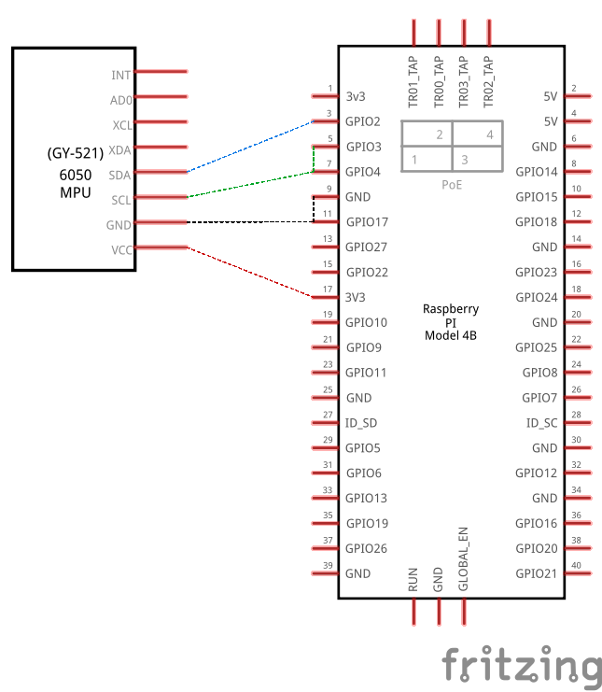

# Sample Code

The sample code for this repository is in Github <https://github.com/Microshak/pi_iot_environment_monitor>.